Special Educational Needs and Disabilities (SEND) Information Report
Dunton Green Primary School


Inclusion Team

SEND Governor:
Sarah Bushell

SENDCO:
Kelly James

Contact No. 01732 462221

Contact emails – SENDCO@dunton-green.kent.sch.uk

Approved by: |  | Date:
Last reviewed on:
Next review due by:

Contents
1. What types of SEND does the school provide for? 4
2. Which staff will support my child? 5
3. What should I do if I think my child has SEND? 7
4. What happens if the school identifies a need? 8
5. How will the school measure my child’s progress? 9
6. How will I be involved in decisions made about my child’s education? 10
7. How will my child be involved in decisions made about their education? 11
8. How will the school adapt its teaching for my child? 12
9. How will the school evaluate whether the support in place is helping my child? 13
10. How will the school ensure my child has appropriate resources? 13
11. How will the school make sure my child is included in activities alongside pupils who don’t have SEND? 14
12. How does the school make sure the admissions process is fair for pupils with SEN or a disability? 15
13. How does the school support pupils with disabilities? 15
14. How will the school support my child’s mental health and emotional and social development? 16
15. What support is in place for looked-after and previously looked-after children with SEN? 16
16. What support will be available for my child as they transition between classes or settings or in preparing for adulthood? 17
17. What support is available for me and my family? (Local Offer) 18
18. What should I do if I have a complaint about my child’s SEND support? 19
19. Supporting Documents…………………………………………………………………………………………………………….19
20. Glossary 20

Dear parents and carers,
The aim of this Information Report is to explain how we implement our SEND policy. In other words, we want to show you how SEND support works in our school.
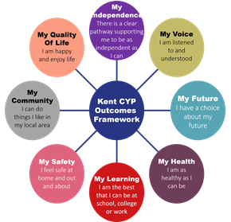
As educational professionals, we are all working towards the ultimate goal of growing independent young people as they prepare for adulthood. All provision and support we provide is working towards achieving the Kent Children and Young People (CYP) Outcomes Framework:

If you want to know more about our arrangements for SEND, read our SEND policy alongside this Information Report.
You can find our SEND policy on our website.
Note: If there are any terms we have used in this information report that you are unsure of, you can look them up in the Glossary at the end of the report.

1. What types of SEND does the school provide for?

Our school provides for pupils with the following needs (as outlined in the SEND Code of Practice 2015):

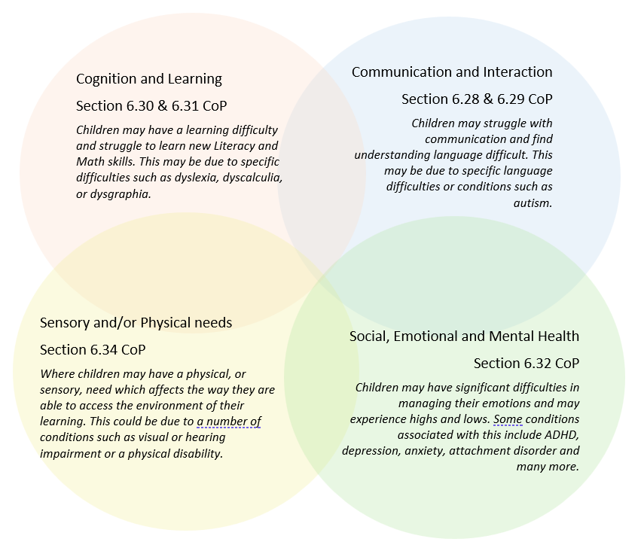

Often you will find that children’s needs overlap and are rarely confined to one area of need, which is why it is important to gain a wholistic overview of your child.
More information about the Areas of Need can be found in the Special educational needs and disability code of practice: 0 to 25 years (link below).
SEND_Code_of_Practice_January_2015.pdf (publishing.service.gov.uk)


2. Which staff will support my child, and what are their key responsibilities?

At Dunton Green, all staff are considered responsible for supporting the needs of pupils with SEND. Our staff are committed to regular, high-quality training to ensure that they have the knowledge and skills to better meet a wide range of pupil needs.
Below outlines key staff who will be supporting your child.

Head of School – Mrs Daisy Holliday
SEND Governor – Sarah Bushell
Mrs Holliday, Head of School, will oversee the SENDCO and class teachers in ensuring the child’s needs are met and keep the Governing Body up to date about all SEND issues.
The SEND Governor, Sarah Bushell, is responsible for ensuring the necessary support is given for any child with SEND who attends the school.
Our Special Educational Needs Co-ordinators, or SENDCOs

SENDCO – Miss Kelly James 
Miss James is a qualified teacher, part of the senior leadership team and holds the National Award in Special Educational Needs Co-ordination.
The SENDCO is responsible for developing and reviewing the school’s SEND policy, liaising with outside professionals supporting children, updating the SEND register (a system for ensuring that all the SEND needs of pupils in the school are known) and monitoring the progress of students with SEND alongside the senior leadership team. The SENDCO will also provide specialist support for teachers and support staff in the school, so that they can help children with SEND in the school to achieve the best progress possible.
Class/subject teachers
All of our teachers receive in-house SEN training, and are supported by the SENDCO to meet the needs of pupils who have SEN.
Teachers are trained in child protection, the understanding of the SEND Code of Practice, the mainstream core standards and the recognition of different areas of need within SEND. Further training on the different categories of need is updated yearly, this includes, dyslexia, dyscalculia, ASD and ADHD.
Teaching partners (TPs)
We have a team of TPs, including higher-level teaching assistants (HLTAs) who are trained to deliver SEN provision.
We have teaching partners who are trained to deliver interventions such as Sensory Circuits, language link, Little Wandle phonics and BEAM.
External agencies
Sometimes we need extra help to offer our pupils the support that they need. Whenever necessary we will work with external support services to meet the needs of our pupils with SEND and to support their families. These may include:

- Child and adolescent mental health services (CAMHS)
- Education welfare officers
- Educational psychologists
- GPs or paediatricians
- NELFT practitioners
- Occupational therapists
- Safeguarding services
- School Liaison Officer
- School nurses
- SEND Inclusion Advisor
- Specialist Teacher Service



Speech and language therapists

3. What should I do if I think my child has SEND?

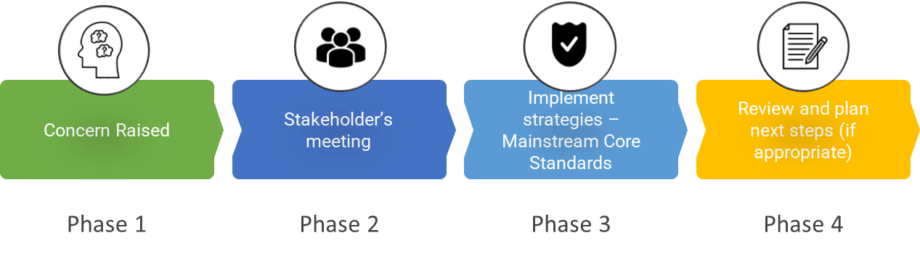

Phase 1 | If you think your child might have SEND, raise your concern with the school so that the SENDCO is aware.  To arrange a meeting with either your child’s class teacher or the SENDCO please either message them on Class Dojo, speak to them before or after school or see Mrs Daniels in the office and she will ask them to contact you.
Phase 2 | We will meet with you to discuss your concerns and try to get a better understanding of what your child’s strengths and difficulties are. Together we will decide what outcomes to seek for your child and agree on next steps.
Phase 3 | We will implement the agreed strategies and monitor these over an agreed period of time. These are likely to be universal strategies set out in the mainstream core standards. A copy of this can be found here: https://www.kelsi.org.uk/__data/assets/pdf_file/0005/117257/Special-educational-needs-mainstream-core-standards-guide-for-parents.pdf . This will initiate the ‘Graduated Approach’ where support will be continually reviewed. See next page for more details.
Phase 4 | If we decide that your child needs SEND support, we will formally notify you and your child will be added to the school’s SEND register. They will receive additional support and this will be reviewed using the assess, plan, do, review model.

4. What happens if the school identifies a need?
The same process is followed if a concern is raised by the school.

All our class teachers are responsible for the monitoring of all pupils who have been identified as having SEND. They also review those who are not making the expected level of progress in their schoolwork or socially.
If the teacher notices that a pupil is having difficulties, they try to find out if the pupil has any gaps in their learning. If they can find a gap, the school will provide appropriate support. Pupils who don’t have SEND usually make progress quickly once the gap in their learning has been filled.
If the pupil is still finding it difficult to make the expected progress, the teacher will talk to the SENDCO, and will contact you to discuss the possibility that your child has SEND, and the school will follow the graduated approach (see previous page).

5. How will the school measure my child’s progress?
Your child’s progress will be continually monitored by their teacher. Their progress will be formally reviewed by the SENDCo, class teacher and Head of School every term following maths, reading, writing and GPS assessments.
The progress of children with an Education, Health Care Plan will be formally reviewed at an annual review with all adults involved with the child’s education. The SENDCO will also check that your child is making progress within any individual work and in any intervention group they take part in. progress meetings for each class are held on a regular basis.
We will follow the ‘graduated approach’ to meeting your child’s SEND needs.
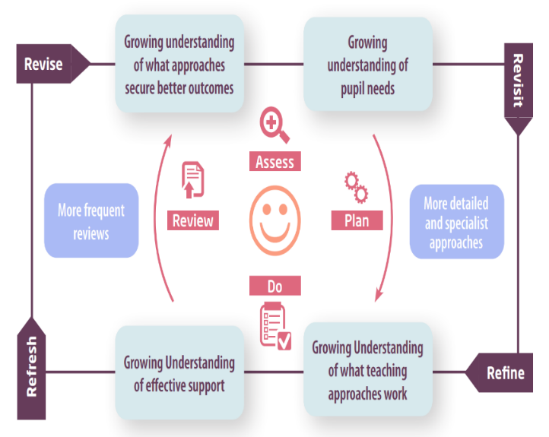
The graduated approach is a 4-part cycle of assess, plan, do, review.

Assess | If your child is not making the expected level of progress, we will make an assessment to find out what strengths and difficulties your child has. We will ask for you and your child’s input, as well as getting help from external professionals where necessary.
Plan | In discussion with you and your child, we will decide what outcomes we are hoping to achieve. We will make a plan of the support we will offer your child to help them meet those outcomes. We will make a record of this and share it with you and all relevant school staff.
Do | We will put our plan into practice.  The class teacher, with the support of the SENDCO, will be responsible for working with your child on a daily basis, and making sure the support we put in place is having the impact we intended.
Review | We will assess how well the support we put in place helped the pupil to meet the outcomes we set. We will use our improved understanding of your child’s needs to improve the support we offer; this may mean the Plan, Assess, Do, Review cycle continues.

6. How will I be involved in decisions made about my child’s education?
We will provide bi-yearly reports on your child's progress.
A member of staff who knows your child well will meet you termly to:
- Set clear outcomes for your child’s progress
- Review progress towards those outcomes
- Discuss the support we will put in place to help your child make that progress
- Identify what we will do, what we will ask you to do, and what we will ask your child to do
The SENDCO will also attend these meetings to provide extra support.
We know that you’re the expert when it comes to your child’s needs and aspirations. So, we want to make sure you have a full understanding of how we’re trying to meet your child’s needs, so that you can provide insight into what you think would work best for your child.
We also want to hear from you as much as possible so that we can build a better picture of how the SEND support we are providing is impacting your child outside of school.
If your child’s needs or aspirations change at any time, please let us know right away so we can keep our provision as relevant as possible.
If you have concerns that arise between these meetings, or would like an update on your child’s progress please contact Miss James (SENDCO) on SENDCO@dunton-green.kent.sch.uk

7. How will my child be involved in decisions made about their education?

The level of involvement will depend on your child’s age and individual needs. We recognise that no two pupils are the same, so we will decide on a case-by-case basis, with your input.

We may seek your child’s views by asking them to:
- Attend meetings to discuss their progress and outcomes
- Prepare a presentation, written statement, video, drawing, etc.
- Discuss their views with a member of staff who can act as a representative during the meeting
- Complete a survey



8. How will the school adapt its teaching for my child?
Your child’s teacher is responsible and accountable for the progress and development of all the pupils in their class.
High-quality teaching is our first step in responding to your child’s needs. We will make sure that your child has access to a broad and balanced curriculum in every year they are at our school.
We will adapt our approaches to how we teach to suit the way the pupil works best. There is no 'one size fits all’ approach to adapting the curriculum, we work on a case-by case basis to make sure the adaptations we make are meaningful to your child and are guided by the Mainstream Core Standards in the first instance.

These adaptations may include:
- Adapting our approaches, for example, giving longer processing times, pre-teaching of key vocabulary, reading instructions aloud, etc.

- Adapting our resources

- Using recommended aids, such as laptops, coloured overlays, visual timetables, now and next boards, larger font, etc.

- Teaching partners or support staff will support pupils appropriately depending on their presentation of need

- Scaffolding lesson materials
We may also provide the following interventions:
- Sensory Circuits
- BEAM
- Comprehension interventions
- Clever Fingers
- Speech and Language
- Little Wandle Phonics interventions
- Handwriting interventions
These interventions are part of our contribution to Kent County Council’s local offer.

9. How will the school evaluate whether the support in place is helping my child?
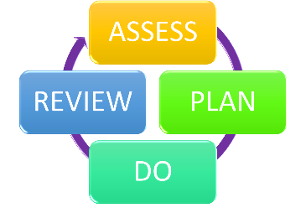
We will evaluate the effectiveness of provision for your child by:
- Reviewing their progress towards their goals each term
- Reviewing the impact of interventions after 6 weeks
- Using pupil questionnaires
- Monitoring by the SENDCO
- Using provision maps to measure progress
- Holding an annual review (if they have an education, health and care (EHC) plan)

10. How will the school ensure my child has appropriate resources?

It may be that your child’s needs mean we need to provide additional resources such as:
- Additional resources to support their learning
- Adaptations to in class support
- Further training for our staff
- External specialist expertise
Where appropriate, we will consult with external agencies to get recommendations on what will best help your child access their learning and use our best endeavours to ensure these are supplied.

11. How will the school make sure my child is included in activities alongside pupils who don’t have SEND?


The expectation is that all schools providing an inclusive provision for all pupils. It may be necessary for some pupils to receive interventions in addition to a broad and balanced curriculum.
All of our extra-curricular activities and school visits are available to all our pupils, including our after-school clubs.
All pupils are encouraged to go on our school trips, including our residential trips in years 2, 4 and 6.
All pupils are encouraged and supported to be fully involved in all areas of school life.
No pupil is ever excluded from taking part in these activities because of their SEN or disability and we will make whatever reasonable adjustments are needed to make sure that they can be included. For pupils with medical/physical needs a care plan will be discussed and set up between the school and parents. For children with SEND the school and parents will discuss the best way to support the child.

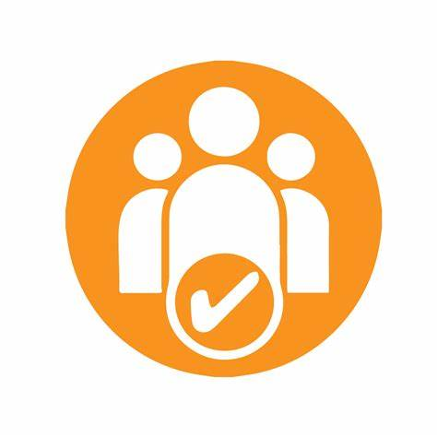
12. How does the school make sure the admissions process is fair for pupils with SEN or a disability?

- The over-subscription criteria for all Community and Voluntary Controlled Infant, Junior and Primary Schools are as follows. Before the application of oversubscription criteria, children with a statement of special educational need or Education, Health and Care Plan which names the school will be admitted. As a result of this, the published admissions number will be reduced accordingly.
- Medical, health, social and special access reasons will be applied in accordance with the school’s legal obligations, particularly those under the Equality Act 2010. Priority will be given to those children whose mental or physical impairment means they have a demonstrable and significant need to attend a particular school. Equally this priority will apply to children whose parents’/guardians’ physical or mental health or social needs mean that they have a demonstrable and significant need to attend a particular school. Such claims will need to be supported by written evidence from a suitably qualified medical or other practitioner who can demonstrate a special connection between these needs and the school.

13. How does the school support pupils with disabilities?


You’re disabled under the Equality Act 2010 if you have a physical or mental impairment that has a ‘substantial’ and ‘long-term’ negative effect on your ability to do normal daily activities.
Dunton Green primary school is spread over one storey and is accessible via ramps or steps. There is an elevator in the Key Stage 2 corridor for any children who cannot access the building via steps (there are 3). The corridors are wide and well lit.
Dunton Green has a disabled toilet which is accessible without steps.

14. How will the school support my child’s mental health and emotional and social development?
We provide support for pupils to progress in their emotional and social development in the following ways:
- Pupils with SEND are encouraged to be part of the school council.
- Pupils with SEND are also encouraged to be part of school clubs to promote teamwork/building friendships.
- We provide extra pastoral support for listening to the views of pupils with SEND.
- We have a ‘zero tolerance’ approach to bullying.

15. What support is in place for looked-after and previously looked-after children with SEND?

Our Family Support Officer, Mrs Hennessey works with Mrs Holliday (Head of School) and Miss James (SENDCO) to make sure that all teachers understand how a looked-after or previously looked-after pupil’s circumstances and their SEND might interact, and what the implications are for teaching and learning.
Pupils who are looked-after or previously looked-after will be supported much in the same way as any other child who has SEND. However, looked-after pupils will also have a personal education plan (PEP). We will make sure that the PEP and any SEND support plans or EHC plans are consistent and complement one another.

16. What support will be available for my child as they transition between classes or settings or in preparing for adulthood?
Between years

To help pupils with SEND be prepared for a new school year we:
- Ask both the current teacher and the next year’s teacher to attend final meeting of the year when the pupil’s SEND is discussed.
- Schedule transition times with the incoming teacher towards the end of the summer term.
Between schools
When your child is moving on from our school, we will ask you and your child what information you want us to share with the new setting.
The SENDCO of the secondary school will come into our school for a meeting with our SENDCO. They will discuss the needs of all the pupils who are receiving SEND support.
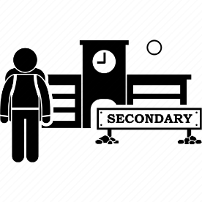
Pupils will be prepared for the transition by:
- Learning how to get organised independently.
- Plugging any gaps in knowledge.
- PSHE sessions about transition and Secondary school.
Transition from another primary within year
The SENDCO of the primary school meets and hands over with our SENDCO to discuss the needs of the incoming pupils near the end of the summer term.
We arrange meetings with the parents of incoming pupils to discuss how we can best welcome their child into our community.

17. What support is available for me and my family?
If you have questions about SEND, or are struggling to cope, please get in touch to let us know. We want to support you, your child and your family.
To see what support is available to you locally, have a look at your local authority’s local offer. Kent County Council publishes information about the local offer on their website:
Our local special educational needs and disabilities information advice and support services (SENDIASS) organisations are:
IASK (Information, Advice and Support Kent) - https://www.iask.org.uk
National charities that offer information and support to families of pupils with SEND are:
- IPSEA
- SEND family support
- NSPCC
- Family Action
- Special Needs Jungle

18. What should I do if I have a complaint about my child’s SEND support?
A concern or complaint can be made in person, in writing or by telephone. They may also be made by a third party acting on behalf on a complainant, if they have appropriate consent to do so.
Please see the link to the school’s complaint policy.
https://www.dunton-green.kent.sch.uk/page/?title=Policies+and+Documents&pid=18
Complaints about SEND provision in our school should be made to the class teacher in the first instance. They will then be referred to the school’s complaints policy.
If you are not satisfied with the school’s response, you can escalate the complaint. In some circumstances, this right also applies to the pupil themselves.
To see a full explanation of suitable avenues for complaint, see pages 246 and 247 of the SEND Code of Practice.
If you feel that our school discriminated against your child because of their SEND, you have the right to make a discrimination claim to the first-tier SEND tribunal. To find out how to make such a claim, you should visit: https://www.gov.uk/complain-about-school/disability-discrimination
You can make a claim about alleged discrimination regarding:
- Admission
- Exclusion
- Provision of education and associated services
- Making reasonable adjustments, including the provision of auxiliary aids and services
Before going to a SEND tribunal, you can go through processes called disagreement resolution or mediation, where you try to resolve your disagreement before it reaches the tribunal.

https://kentfms.co.uk/#:~:text=Kent%20Family%20Mediation%20is%20the,meetings%20are%20held%20virtually%20online.

19. Supporting documents

- Equality Information and Objectives Policy
- Child protection and safeguarding policy
- Behaviour Policy
- Accessibility Plan
- Attendance and punctuality policy
- SEND policy

- SEN & Disabilities Code Of Practice 2015
- Mainstream Core Standards

20. Glossary
- Access arrangements – special arrangements to allow pupils with SEND to access assessments or exams
- Annual review – an annual meeting to review the provision in a pupil’s EHC plan
- Area of need – the 4 areas of need describe different types of needs a pupil with SEND can have. The 4 areas are communication and interaction; cognition and learning; physical and/or sensory; and social, emotional and mental health needs.
- CAMHS – child and adolescent mental health services
- Differentiation – when teachers adapt how they teach in response to a pupil’s needs
- EHC needs assessment – the needs assessment is the first step on the way to securing an EHC plan. The local authority will do an assessment to decide whether a child needs an EHC plan.
- EHC plan – an education, health and care plan is a legally-binding document that sets out a child’s needs and the provision that will be put in place to meet their needs.
- First-tier tribunal/SEND tribunal – a court where you can appeal against the local authority’s decisions about EHC needs assessments or plans and against discrimination by a school or local authority due to SEND
- Graduated approach – an approach to providing SEND support in which the school provides support in successive cycles of assessing the pupil’s needs, planning the provision, implementing the plan, and reviewing the impact of the action on the pupil
- Intervention – a short-term, targeted approach to teaching a pupil with a specific outcome in mind
- Local offer – information provided by the local authority which explains what services and support are on offer for pupils with SEND in the local area
- Outcome – target for improvement for pupils with SEND. These targets don't necessarily have to be related to academic attainment
- Reasonable adjustments – changes that the school must make to remove or reduce any disadvantages caused by a child’s disability
- SENDCO – the special educational needs co-ordinator
- SEN – special educational needs
- SEND – special educational needs and disabilities
- SEND Code of Practice – the statutory guidance that schools must follow to support pupils with SEND
- SEND information report – a report that schools must publish on their website, that explains how the school supports pupils with SEND
- SEND support – special educational provision which meets the needs of pupils with SEND
- Transition – when a pupil moves between years, phases, schools or institutions or life stages

